MicroServices Handson
Question 1: Implement JWT Authentication in ASP.NET Core Web API
1. Project Setup
Content:
- Created an ASP.NET Core Web API project.
- Installed the required JWT authentication package.
Screenshot:
- Project created in Visual Studio / VS Code
- NuGet package installation:
Command:
dotnet add package Microsoft.AspNetCore.Authentication.JwtBearer
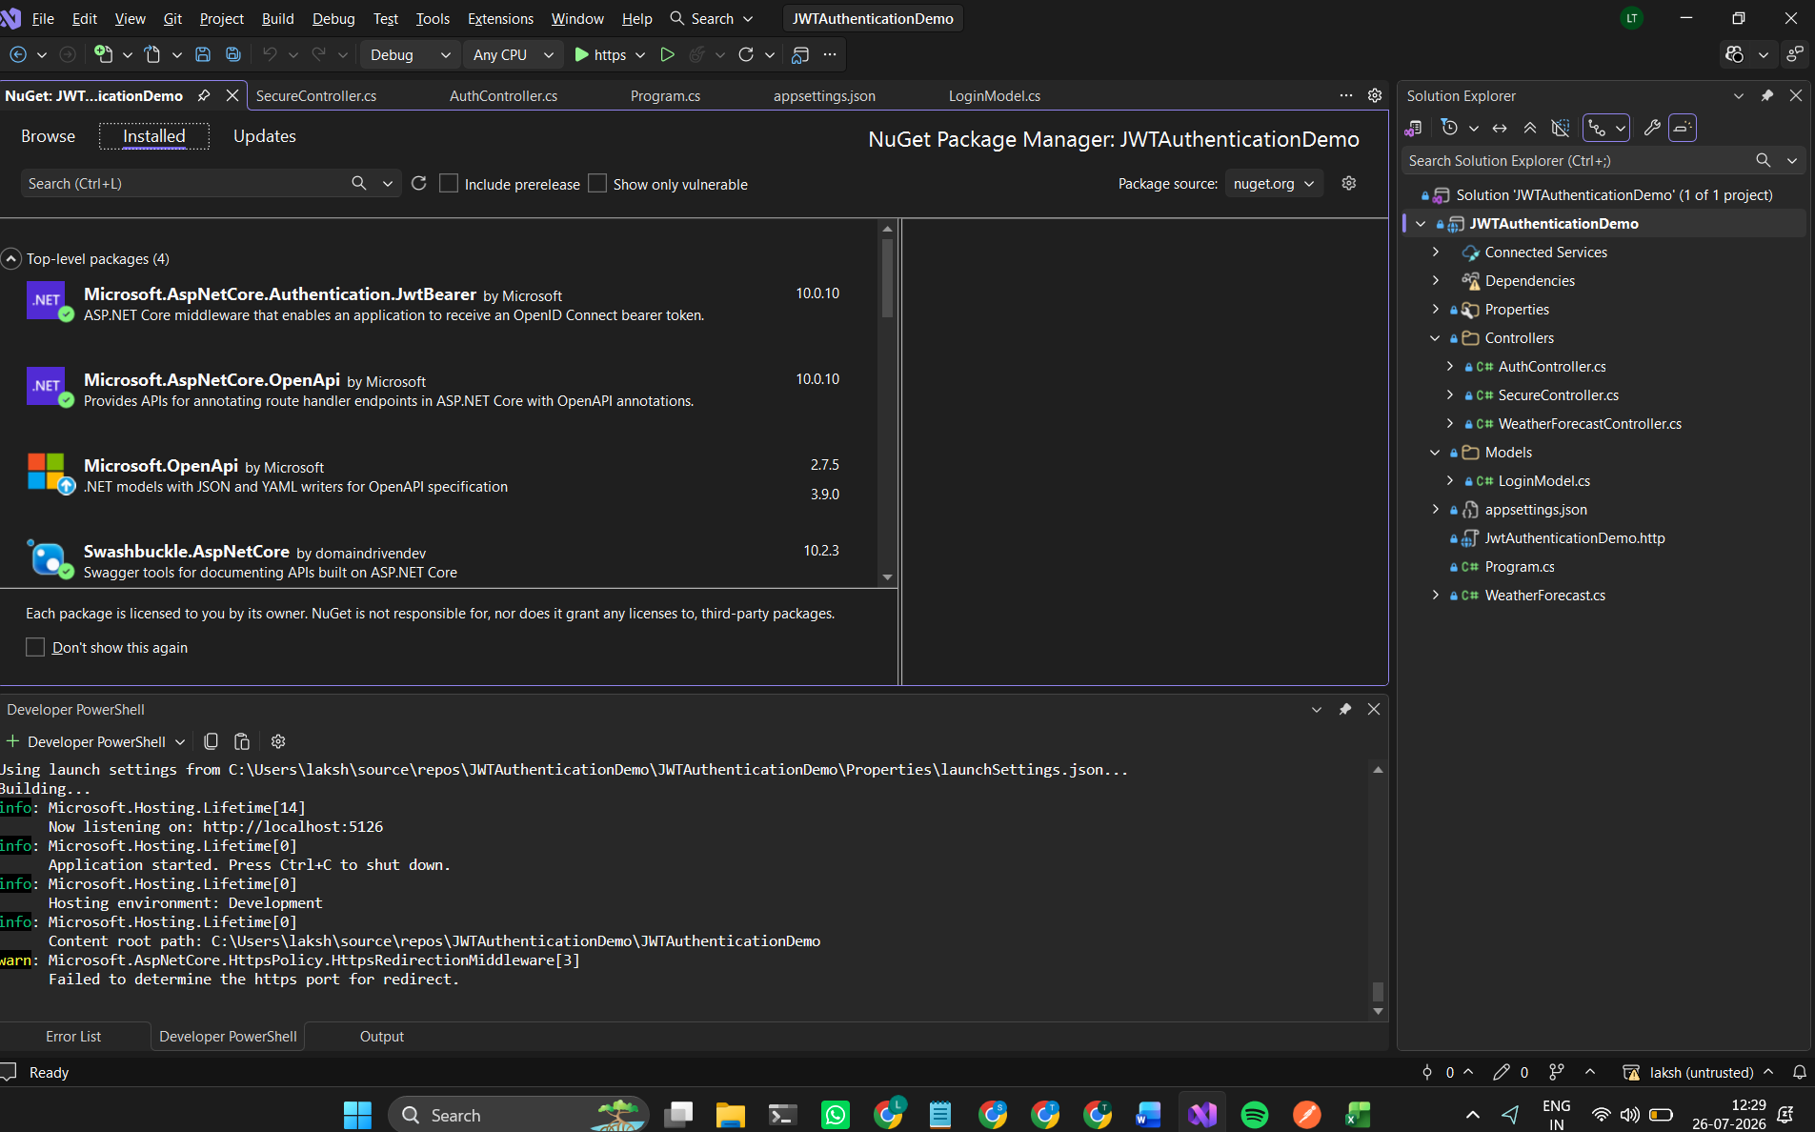

2. JWT Configuration
Content:
JWT settings are configured in appsettings.json including:
- Secret Key
- Issuer
- Audience
- Token expiry duration
Code:
"Jwt": {
"Key": "ThisIsASecretKeyForJwtToken1234567890",
"Issuer": "MyAuthServer",
"Audience": "MyApiUsers",
"DurationInMinutes": 60
},
"Logging": {
"LogLevel": {
"Default": "Information",
"Microsoft.AspNetCore": "Warning"
}
},
"AllowedHosts": "*"
}

3. Configuring JWT Authentication
Content:
JWT Bearer authentication was configured in Program.cs to validate:
- Token issuer
- Token audience
- Token lifetime
- Signing key

using Microsoft.AspNetCore.Authentication.JwtBearer;
using Microsoft.IdentityModel.Tokens;
using System.Text;
var builder = WebApplication.CreateBuilder(args);
// Add Controllers
builder.Services.AddControllers()
// Swagger
builder.Services.AddEndpointsApiExplorer();
builder.Services.AddSwaggerGen();
// JWT Authentication
builder.Services.AddAuthentication(
JwtBearerDefaults.AuthenticationScheme
)
.AddJwtBearer(options =>
{
options.TokenValidationParameters = new TokenValidationParameters
{
ValidateIssuer = true,
ValidateAudience = true,
ValidateLifetime = true,
ValidateIssuerSigningKey = true,
ValidIssuer = builder.Configuration["Jwt:Issuer"],
ValidAudience = builder.Configuration["Jwt:Audience"],
IssuerSigningKey = new SymmetricSecurityKey(
Encoding.UTF8.GetBytes(
builder.Configuration["Jwt:Key"]!
))
};
});
// Authorization
builder.Services.AddAuthorization();
var app = builder.Build();
if (app.Environment.IsDevelopment())
{
app.UseSwagger();
app.UseSwaggerUI();
}
app.UseHttpsRedirection();
app.UseAuthentication();
app.UseAuthorization();
app.MapControllers();
app.Run();
4. Login Endpoint and Token Generation
Content:
An authentication controller was created with a login endpoint.
When valid user credentials are provided:
- A JWT token is generated.
- The token is returned to the client.

using JwtAuthenticationDemo.Models;
using Microsoft.AspNetCore.Mvc;
using Microsoft.IdentityModel.Tokens;
using System.IdentityModel.Tokens.Jwt;
using System.Security.Claims;
using System.Text;

namespace JwtAuthenticationDemo.Controllers
{
[ApiController]
[Route("api/[controller]")]
public class AuthController : ControllerBase
{
[HttpPost("login")]
public IActionResult Login(LoginModel model)
{
if (IsValidUser(model))
{
var token = GenerateJwtToken(model.Username);

return Ok(new
{
Token = token
});
}

return Unauthorized();
}

private bool IsValidUser(LoginModel model)
{
return model.Username == "admin" &&
model.Password == "12345";
}

private string GenerateJwtToken(string username)
{
var claims = new[]
{
new Claim(ClaimTypes.Name, username)
};

var key = new SymmetricSecurityKey(
Encoding.UTF8.GetBytes("ThisIsASecretKeyForJwtToken1234567890"));

var credentials = new SigningCredentials(
key,
SecurityAlgorithms.HmacSha256);

var token = new JwtSecurityToken(
issuer: "MyAuthServer",
audience: "MyApiUsers",
claims: claims,
expires: DateTime.Now.AddMinutes(60),
signingCredentials: credentials);

return new JwtSecurityTokenHandler().WriteToken(token);
}
}
}

5. Securing API Endpoint Using JWT
Content:
The API endpoint was secured using the [Authorize] attribute.
Only requests containing a valid JWT token can access this endpoint.
Example:
[Authorize]
[HttpGet]
public IActionResult GetData()
{
return Ok("You accessed protected API using JWT!");
}
6. Testing JWT Authentication
6.1 Login API Request
Content:
User credentials were sent to the login endpoint to generate a JWT token.
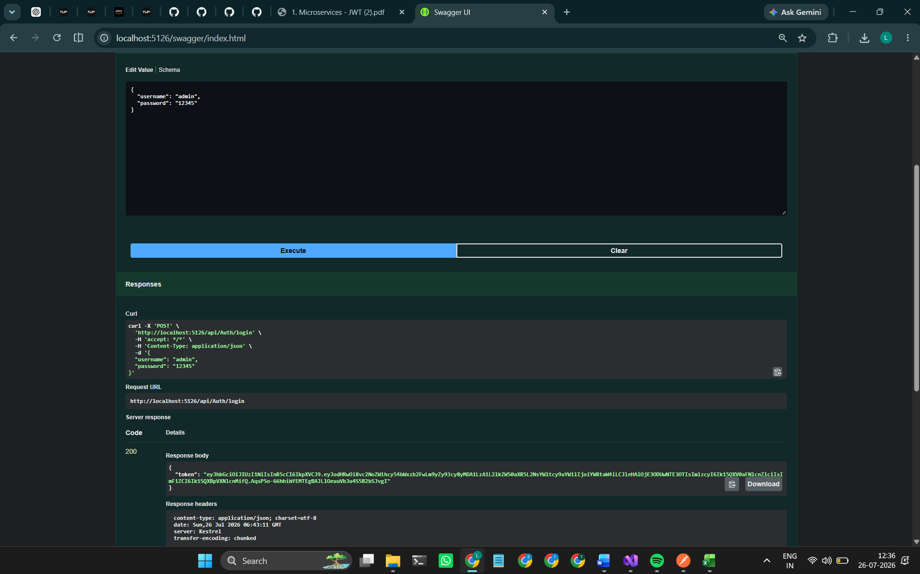
6.2 Accessing Protected API
Content:
The generated JWT token was added in the Authorization header as a Bearer token.
6.3 Protected API Response
Content:
After successful JWT validation, the protected API returned the response.

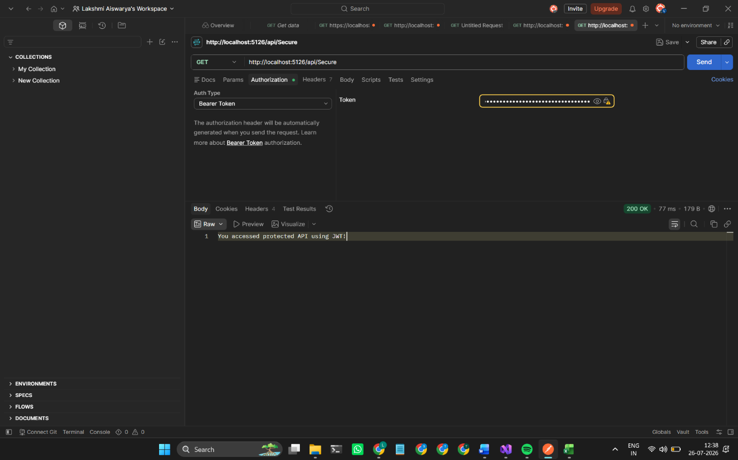
Conclusion
JWT authentication was successfully implemented in ASP.NET Core Web API. The API now generates JWT tokens during login and protects secured endpoints using token-based authentication.

